**Contents**

Introduction……………………………………………………………………….

Team Members………………………………………………………………….

Roles………………………………………………………………………………….

Gantt Chart…………………………………………………………………………

Main Work Screenshots…………………………………………………….

Conclusion………………………………………………………………………….

## 

## **INTRODUCTION**

With the help of agile mythology, we create an android application on Quiz App. In this app, there are two user one is admin and another is registered user. Admin user is capable to build quiz according to topic available. User is capable to give quiz and get step by step his/her progress with a timer. And after quiz he/she got the result.

# **TEAM MEMBERS**

**1. Prabhneet Singh Grewal**

**2. Parminder Singh**

**3. Akash Sharma**

## **ROLES**

**Prabhneet Singh Grewal**: Product Owner

**Parminder Singh**: Scrum Master and Stakeholder

**Akash Sharma**: Developer

## **GANTT CHART**

## **Main Work** **SCREENSHOT**

User Table Screen Shot

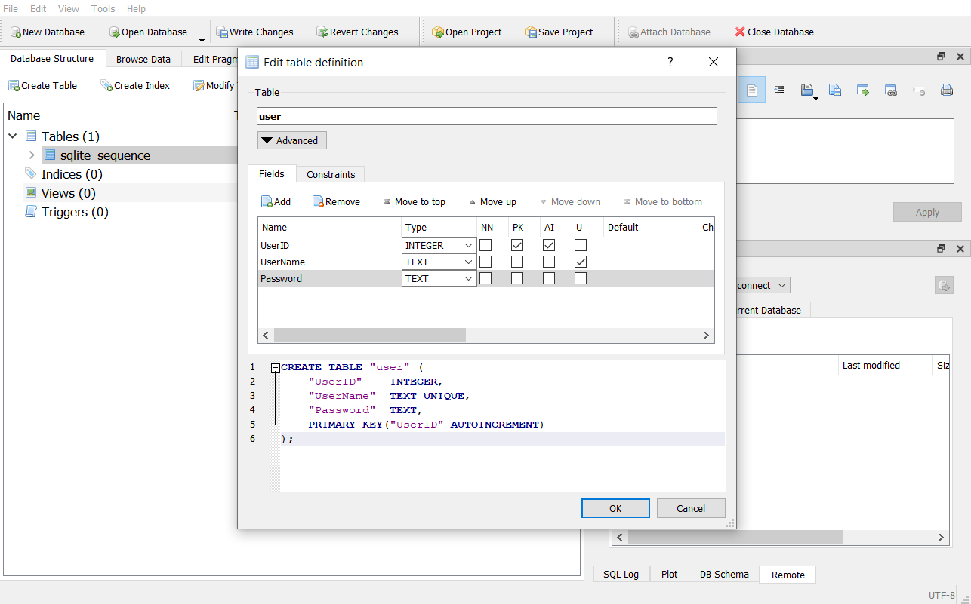

Topic Table Screen Shot

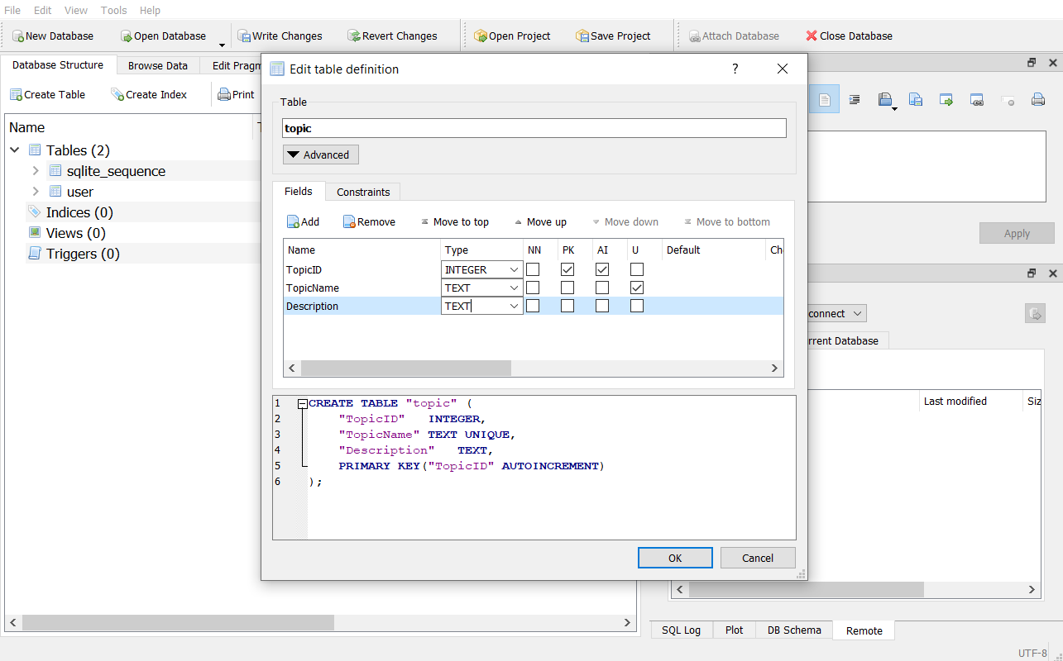

Question Table Screen Shot

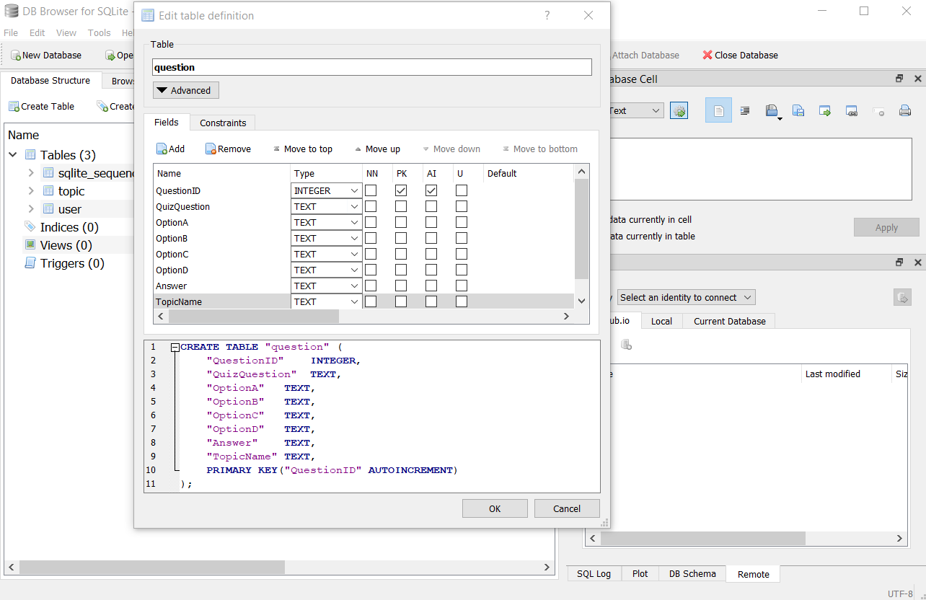

Splash Screen:

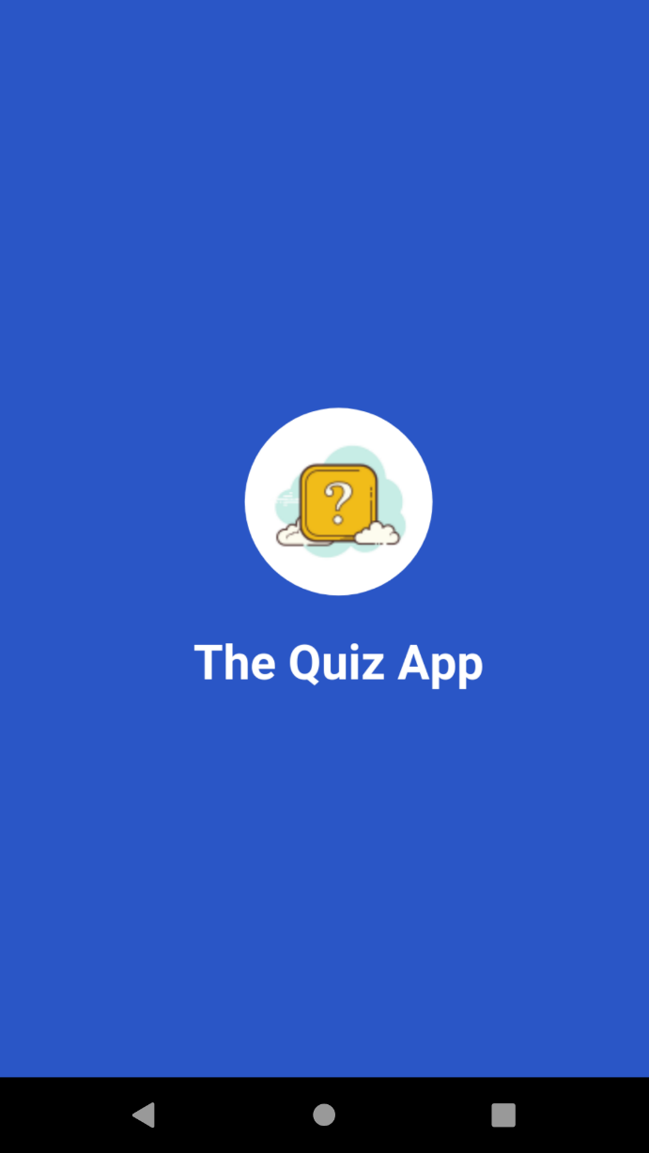

Quiz Home Screen:

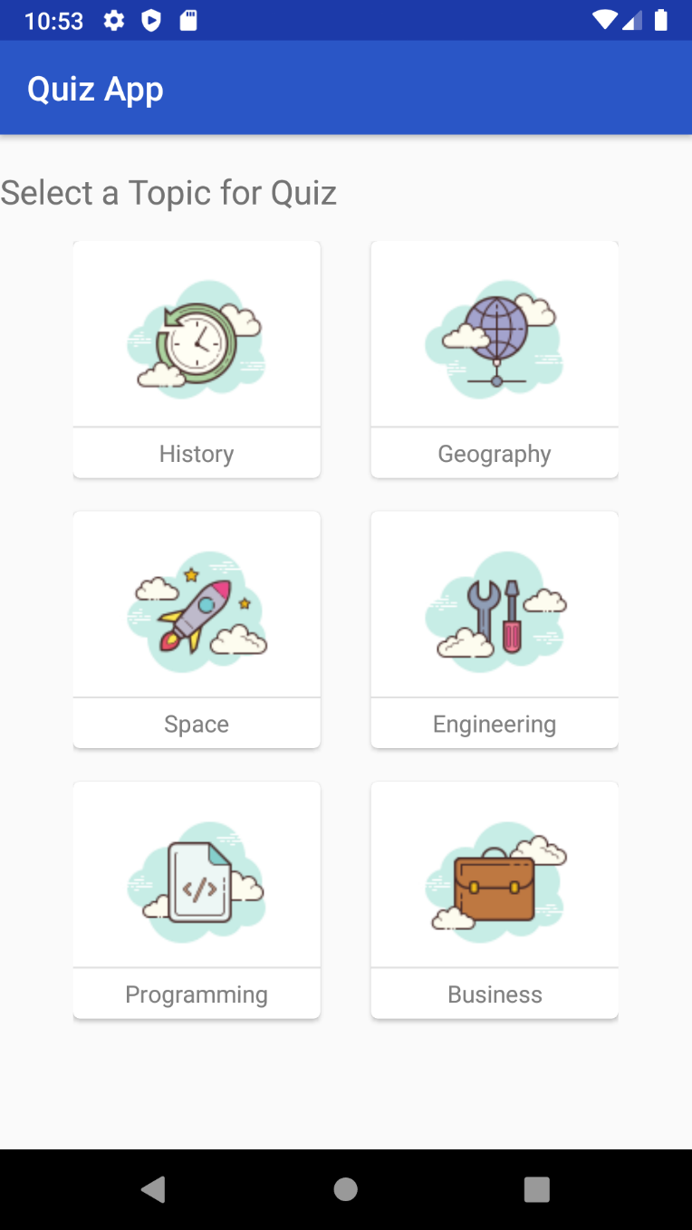

Quiz Description Screen:

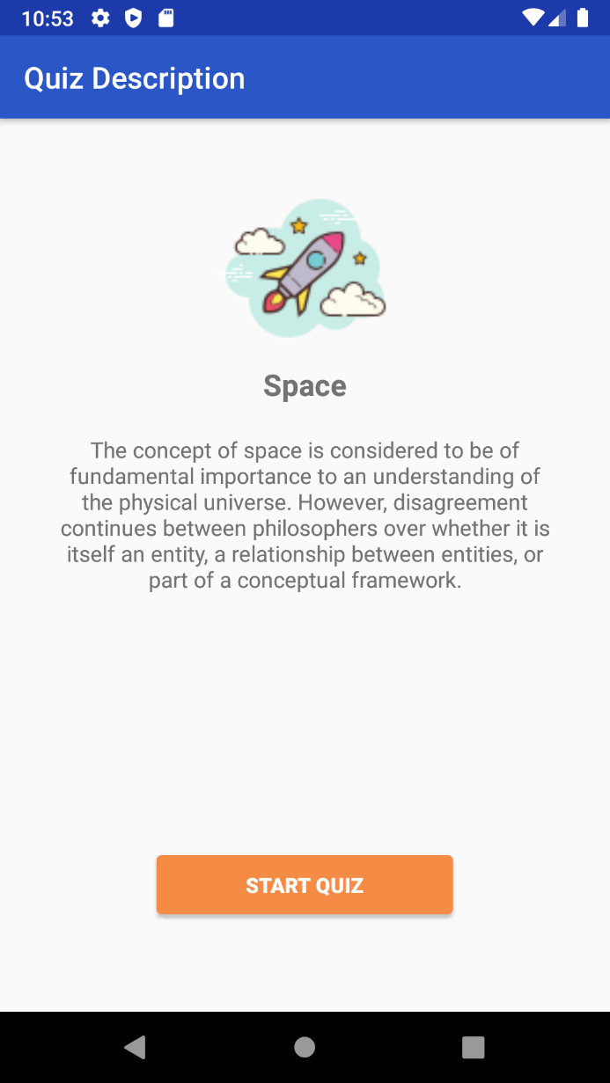

Quiz Screen:

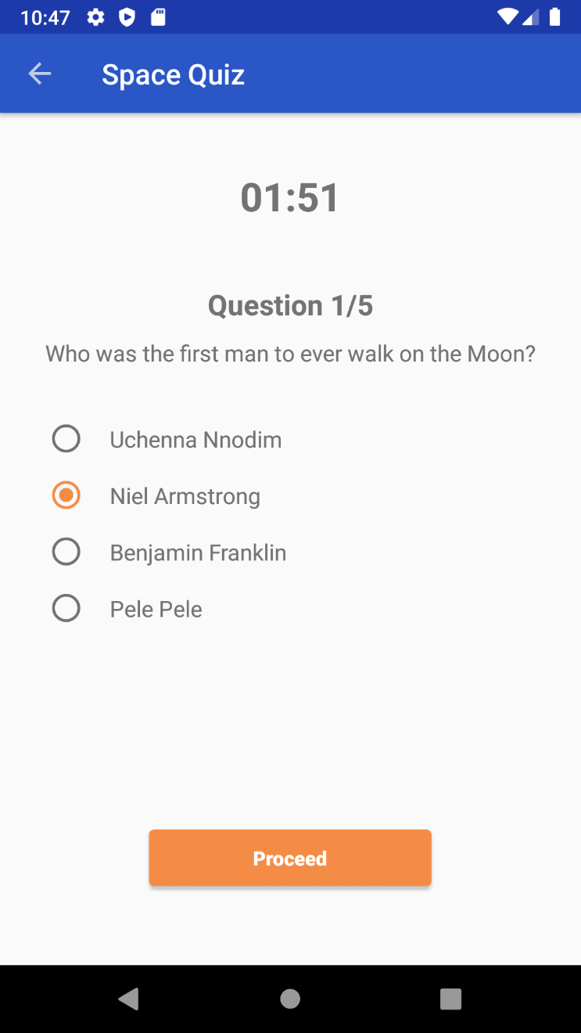

Question Correct Answer Screen:

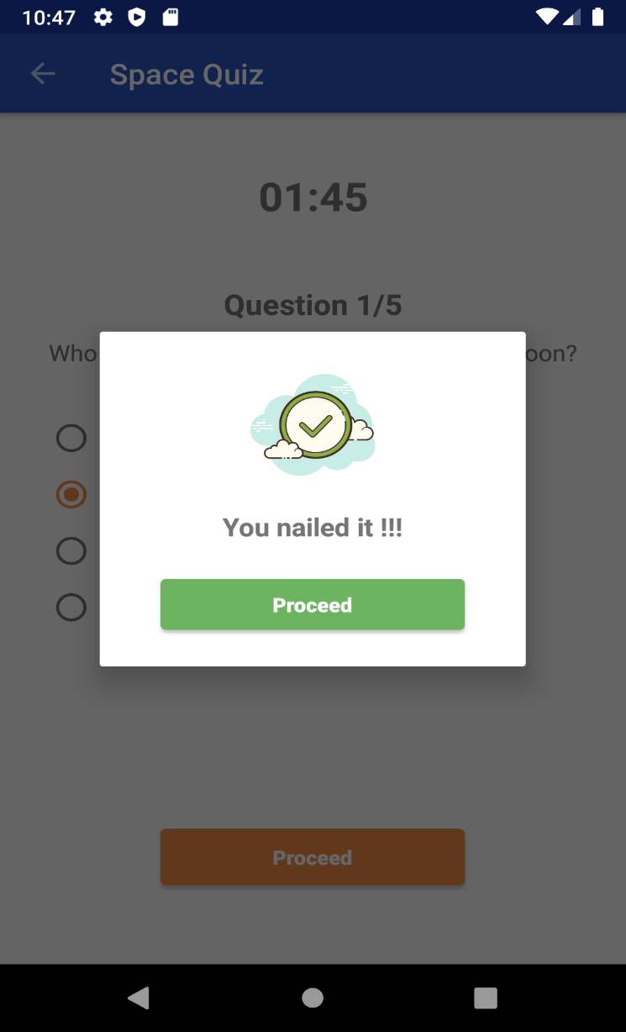

Question Wrong Answer Screen:

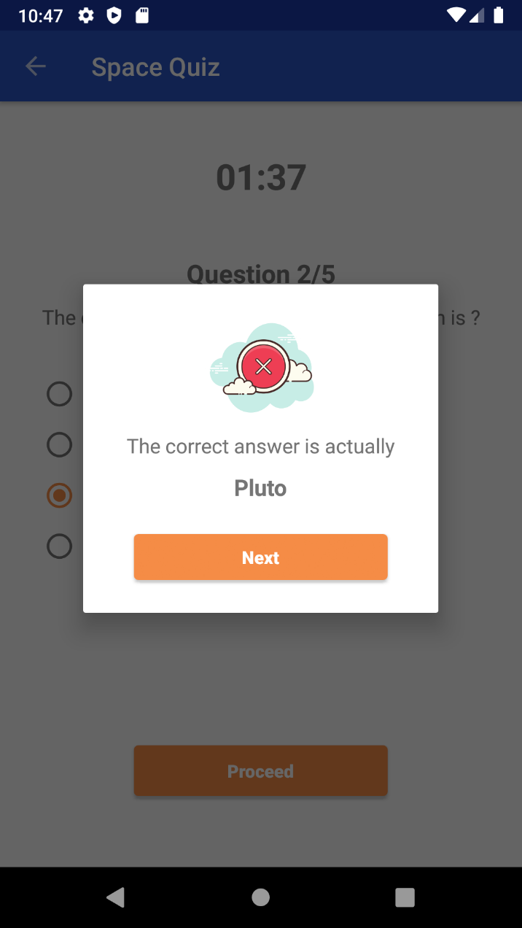

## **Conclusion**

Agile and scrum methodology are used by the project managers for keeping the track of work. As it quickly reacts to changes and is more flexible as compared to others.

To sum up, this application is for the user to register their details to take quiz according to topic mention on their home screen. And all these topic question is managed by Admin.